CS375 Assignment 6
(Due on December 1, 2023 by 11:59pm)

Objective:
- Understand the backtracking algorithms
- Enhance the concept of Intractability and the theory of NP.

1. [12%] Given the following sum of subset problem. S=10, and the integers are 3, 9, 2, 6, 7.
  - [5%] If no pruning is made on the whole state space tree. How many nodes does it contain?
Answer: 2^(5) = 32 nodes.
  - [10%] Apply the backtracking algorithm. Whenever you find that a node is not promising backtrack. How many nodes does your tree contain? Draw the pruned state space tree.
Answer: There will be 13 nodes in the tree.
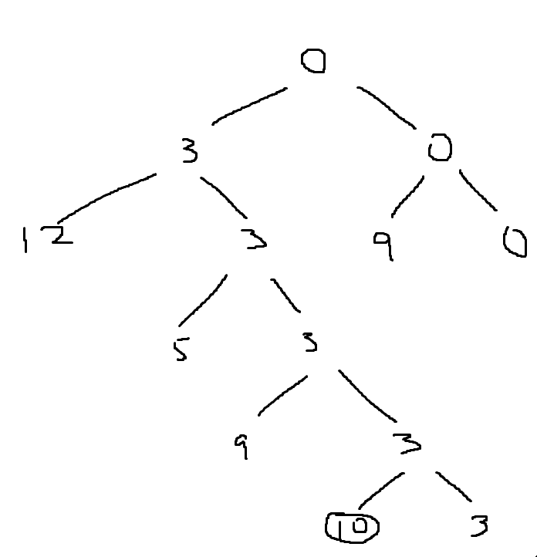

2. [16%]
(1) [8%] Given a knapsack of size 28, and the following 3 items: Item 1, has profit 32 and size 8. Item 2, has profit 110 and size 20. Item 3, has profit 50 and size 5. Solve the problem using the backtracking algorithm. Show the complete pruned state space tree. Show for every node, the current profit, the current weight and the bound. Show also the maxprofit after each node is generated. Show the order that the nodes to be checked.
Answer: 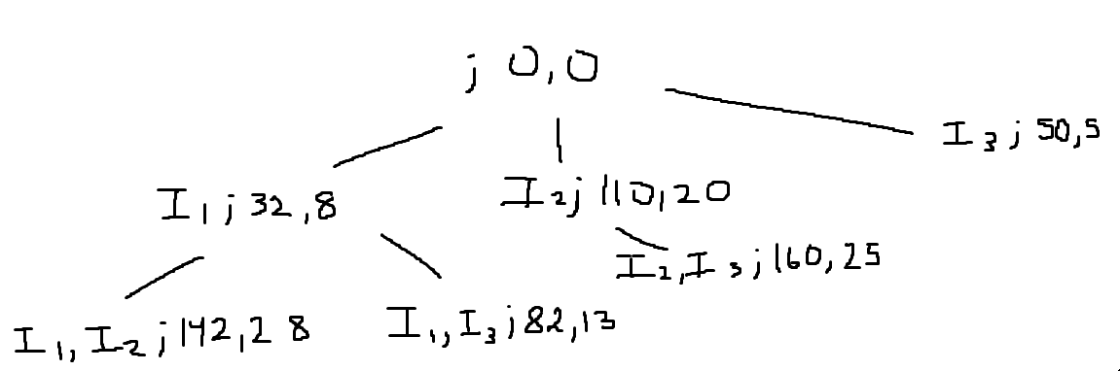
The optimal solution is I2, I3 (160 profit, 25 weight).
(2) [8%] Using the best-first search algorithm (Branch-and-Bound) to solve the above problem. Show the order that the nodes to be checked.
Answer:
 | Items | Wi | Vi | Vi/wi
1 | I3 | 5 | 50 | 10
2 | I2 | 20 | 110 | 5.5
3 | I1 | 8 | 32 | 4

1) Start with root node:
w = 0, v = 0, ub = v + (W – w) (vi + 1 / wi + 1) = 0 + 28 * 10 = 280
2) Include Item I3 on left, exclude I3 on right.
Left branch: w = 5, v = 50, ub = 50 + (28-5) * 5.5 = 176.5
Right branch: w = 0, v = 0, ub = 0 + (28-0) * 5.5 = 154
3) Repeat for Item I3
Left branch:
Left branch: w = 25, v = 160, ub = 160 + (28-25) * 4 = 172
Right branch: w = 5, v = 50, ub = 50 + (28-5) * 4 = 142
Right branch:
Left branch: w = 20, v = 110, ub = 110 + (28-20) * 4 = 142
Right branch: w = 0, v = 0, ub = 0 + (28-0) * 4 = 112
4) Repeat for I1
We cannot find the upper bounds because v4/w4 is not available.

The node with the maximum upper bound is the optimal solution, which is node (w = 25, v = 160, ub = 172). So, the optimal solution is Items I3, I2 with max profit = 160.

3. [10%] Given an array A. Consider the following decision problem: is the 5000th largest element in the array greater than 100000?
    - Does this problem belong to the class P? Explain if no, or describe and analyze a polynomial bound algorithm that solves it. [4%]
Answer: Yes. The problem consists of two parts: first sort the array, and then compare the 5000th element of the array with 100000. The sorting can be done in polynomial time using any common sorting algorithm, such as quick sort (O(nlogn).
    - Does the problem belong to the class NP? Explain [3%]
Answer: Yes, P is a subset of NP, so the problem is in NP since it is already in P.
    - Does it belong to the class NPC (the class of NP-Complete problems)? (yes, no, probably) Explain [3%]
Answer: Probably, because while both P and NP belong in NPC, their mutual inclusion is not clear. So, it is unclear whether the problem is or is not in NPC.

4.[8%] Professor Green showed a polynomial reduction of the famous decision problem CC to an NP-Complete problem. He also wrote an 80 page paper showing a polynomial bound algorithm for solving CC.
- Is CC in P? Is CC in NP? [5%]
Answer: CC is in P as Professor Green found a polynomial-time algorithm to solve CC, which is the defining characteristic of any problem being in P (polynomial time). CC is also in NP since it can be solved in polynomial time (P is a subset of NP). Since CC is in P, it is also in NP.
- Should Professor Green get the $1,000,000 prize for showing that P = NP? Explain your answer. [5 %]
Answer: No. Based on his claims, CC can be reduced to NPC in polynomial time, which indicates that CC is at least as hard as any NP problem, potentially making it NPC itself. He claims that CC is in P given a polynomial-time algorithm can solve CC; however, if CC is both NPC and P, then this implies that P = NP, which would require more evidence due to contradiction.
- [8%] Professor Watson showed a polynomial reduction of satisfiability to the famous decision problem YY. He also showed a polynomial bound verification algorithm for YY.
  - What does Professor Watson know about YY? [5%]
Answer: Professor Watson knows that YY is both NP and NP-hard. We know that satisfiability is YY since both are NP-hard (reduction). If we reduce this, it takes polynomial time, meaning that YY is NP-hard.
  - Assume that the professor find a polynomial bound algorithm for YY. Should Professor Watson get the $1,000,000 prize for showing that P = NP? Explain your answer. [5 %]
Answer: Yes. Assuming that the professor finds a polynomial bound algorithm for YY, the problem YY is NPC and can be solved in polynomial time So, P = NP, where the algorithm can solve other difficult problems so that all NP problems are solvable.

6. [9%] A clique is a complete graph --- every vertex is connected to every other vertex. Here is the formal definition from many textbooks: “A clique in a graph is a set of pair-wise adjacent vertices, or in other words, an induced sub-graph which is a complete graph. In the following graph, vertices 1, 2 and 5 form a clique, because each has an edge to all the others”.
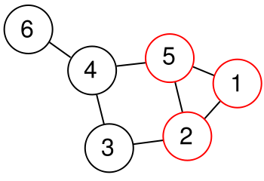

Then, the decision-clique problem is the problem of determining whether a graph G contains a clique of at least a given size k. This problem is NP-complete.
Professor Bartlett has designed an algorithm that can take any graph G with n vertices and determine in 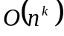 time whether or not G contains a clique of size k. Has Professor Bartlett showed that P = NP? Explain your answer.
Answer: Yes. Professor Bartlett’s algorithm has a time complexity of O(n^k), which is a polynomial algorithm. We know that P is a subset of NP. Therefore, P = NP.

7. [7%] Is the sum of subsets the decision problem or the optimization problem? Is it in NP? Explain why.
Answer: The sum of subsets is the decision problem. It can be divided into two subproblems: a) Include the last element, recur for n = n-1, sum = sum – set[n-1], and b) exclude the last element, recur for n = n-1. If any of the given subproblems are true, then the program returns true. Therefore, the problem is in NP, specifically NPC as it takes exponential time to be solved.

8. [8%] Show that 0-1 knapsack decision problem is NP-Complete (hint: sum of subsets is NP-Complete).
Answer: Consider the problem with two inputs: an array and an integer. The array consists of n items, with each item having a weight and index value. Let the maximum weight = W. Now, say there are 5 items and W = 3. In binary, W = 0011. The time complexity in this case is O(n*W) = O(5*3) = O(15). If the array size is doubled, then the time complexity is O(10*3) = O(30). However, when the size of W is doubled, the binary value is doubled (W = 00110000). Now, the time complexity is O(n*W) = O(5*40) = O(200). This is an exponential increase in time, so the 0-1 knapsack decision problem is NPC.

9. [12%] For each of the following problems, indicate which are in P and which are in NP. For those you think are in P, give an outline of the algorithm to solve them. For those you think are in NP, explain why you think they are not solvable in polynomial time. (Hint: think about an algorithm to solve these problems, and then determine if it is polynomial.)

- The Smarandache function, S(k), gives the smallest integer m, so that m! can be evenly divided by k. For example, S(9) = 6 because 6!=720 and 9 does not divide any smaller factorial. Calculate the Smarandache function for any number.
Answer: This problem is in P because the function can be calculated efficiently through a loop that checks the factorial of each number from 1 onwards until the smallest m is found such that m! is divisible by k.
- You have to seat N children in the smallest number of rows in an auditorium. For each child, you have a list of who that child dislikes. Experience shows that if a child is in the same row or any row behind a child that he or she dislikes, he or she will throw things at the other child. Given this list, determine in which row to seat each child, or determine that they cannot be seated.
Answer: This problem is in NP because a decision is made after exploring all possible combinations of seating arrangements, checking each to ensure no child sits behind a disliked child. This causes exponential growth in the number of possible combinations with the number of children.
- You are in front of a wall that stretches infinitely in both directions. You know that there is a door in the wall, but it is dark, and you have only a dim flashlight that allows you to see no more than one step in either direction. Find the door.
Answer: This problem is in P because it can be solved in constant time, where the algorithm simply moves in one direction until the door is found.

10. (10%) Graph coloring problem is defined as follow: For a given graph, find its chromatic number (the smallest number of colors that need to be assigned to the graph’s vertices so that no two adjacent vertices are assigned the same color).

          - (5%) For each of the following graphs, find its chromatic number

(i) (ii) (iii)
a
e
b
f
g
h
d
c
a
e
b
d
c
a
e
b
f
g
h
d
c
Answer:
i) The chromatic number is 3.
ii) The chromatic number is 2.
iii) The chromatic number is 3.

          - (5%) Design a polynomial-time algorithm for the graph 2-coloring problem: determine whether vertices of a given graph can be colored in no more than two colors so that no two adjacent vertices are colored the same color
Answer:
Input: A graph G=(V,E)
Output: True if G can be colored with 2 colors such that no adjacent vertices share the same color; False otherwise.

2-coloringAlgorithm {
Pick an arbitrary vertex v in G and color it with color 1
For each vertex u in G, excluding v {
If(u is not adjacent to v) Color u with color 1
If(u is adjacent to v) Color u with color 2
}
For each remaining uncolored vertex w in G {
If(w is not adjacent to any colored vertex) Color w with color 1
If(w is adjacent to vertices colored with both colors 1 and 2) return False
If(w is adjacent to vertices colored with only one color) Color w with the other color
}
If(all vertices have been colored without conflict) return True
Else return False
}

11. (Optional: Extra point 12%) using the best-first search algorithm to give a solution of the following traveling salesman problem. Show the state space tree and the optimal tour [7%], and write a program to implement it [5%].

A
B
C
D
4
2
2
3
1
5

